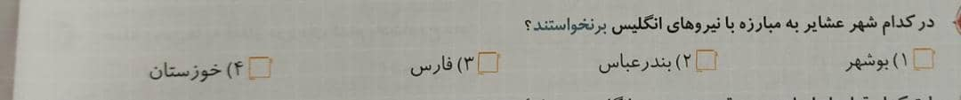

گزینه 2

+++++++++++++++++++++++++++++++++++++++++++++++++++++++++++++++++++++++++++++

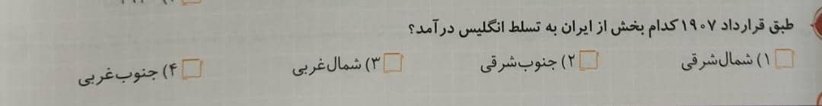

گزینه 2

+++++++++++++++++++++++++++++++++++++++++++++++++++++++++++++++++++++++++++++



گزینه 1

+++++++++++++++++++++++++++++++++++++++++++++++++++++++++++++++++++++++++++++

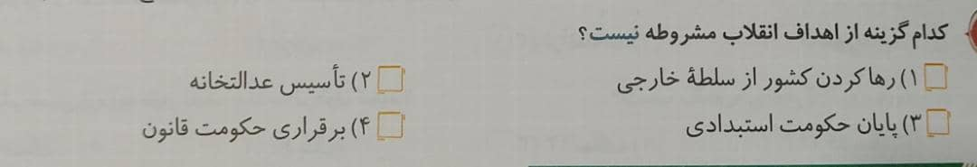

گزینه 2

+++++++++++++++++++++++++++++++++++++++++++++++++++++++++++++++++++++++++++++

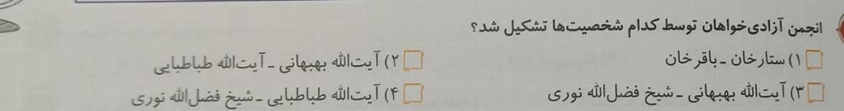

گزینه 2

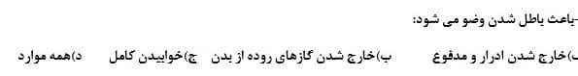

گزینه 4

+++++++++++++++++++++++++++++++++++++++++++++++++++++++++++++++++++++++++++++



گزینه 2

+++++++++++++++++++++++++++++++++++++++++++++++++++++++++++++++++++++++++++++

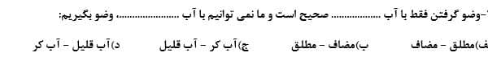

گزینه 1

+++++++++++++++++++++++++++++++++++++++++++++++++++++++++++++++++++++++++++++



گزینه 3

+++++++++++++++++++++++++++++++++++++++++++++++++++++++++++++++++++++++++++++

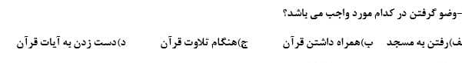

گزینه 4